**Swetha Shree Byllahali Ananthaswamy**

**Information Technology Management**

**IFT-598 Middleware Prog & Database Sec**

**Professor: Dinesh Sthapit**

**Due Date: 12/03/2022**

**Module 8: Assignment Final Project**

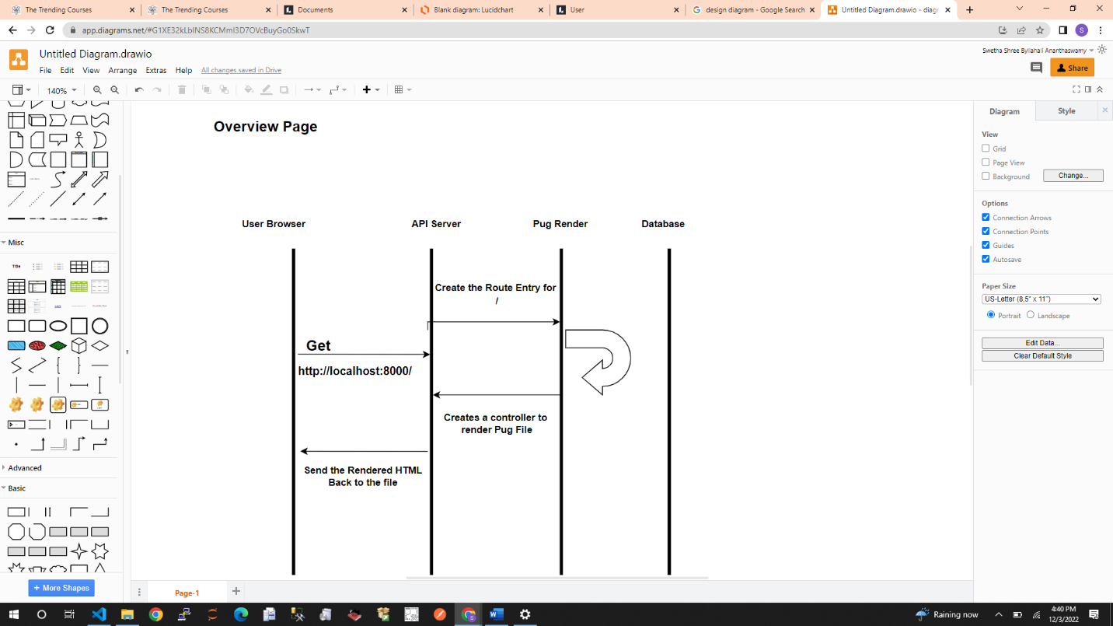

In the Over view Page , The user gets the request <http://localhost:8000/> , it renders the Overview Page from the respective controller.

When the User Hits the get the SignUp Page , in the controller to render the registerUser.pug , Send the Rendered HTML Back to the Client. When the /api/v1/registerUser hits the server, In the controller it verifies if all the fields are filled , password and confirm password are matched and if the user is not present in the DB, it registers and loads the LogIn Page

When the Registration is Successful, The User Hits the login Page, with the message saying “You are now registered , you can sign in”. In the controller , it verifies if the authentication is successful Pops of the error message if any as shown screenshots above. If its successful, it loads the Loan Page. So that we can start applying for the Loans and see the list of the Loans already applied by the user.

Once the Login is successful you can apply for the Loans, we need to enter all the loan related Information in the controller, it will verify all the Loan related information, errors will be validated in the controlled and loan Object is stored in mongo DB.

Some of the Diagrams are shown below , It will Show the restricted access to users.

To Get all the Loan Information by logged In, User will hit on to get all Loan Details api applied by that particular user. Screen Short below shows the rendering part using Pug.

Mongo DB Screenshots are attached below for reference:

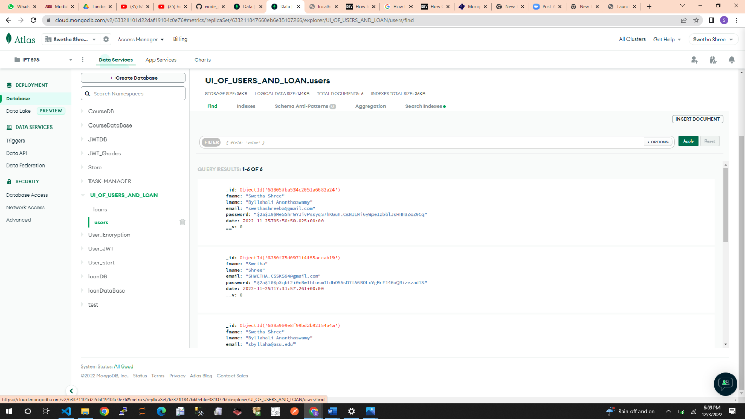

Tested Using Post Man:

